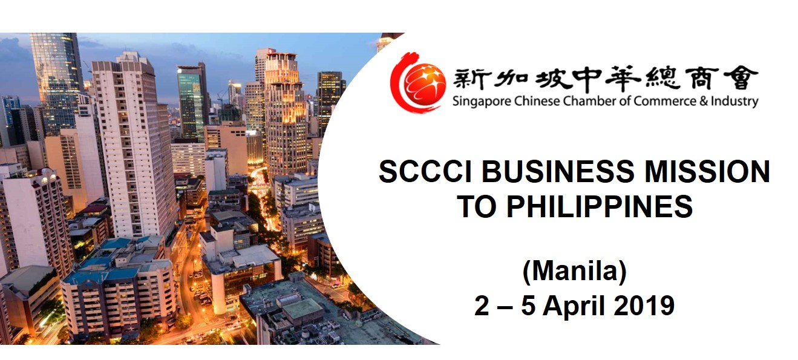
OVERVIEW

The economy of the Philippines is the 3rd largest economy in the ASEAN after Indonesia and Thailand. With the Philippines’ economy expanding and among the top three growth performers in the East Asia region in 2017, the mission to Philippines in 2019 is timely to renew business relationship and pay visits to the local Philippines local Chambers of commerce, government agencies and enterprises, and promote two-way business exchange and cooperation.

The Singapore Chinese Chamber of Commerce & Industry (SCCCI) will be organising a 4 Days Business Mission to Philippines targeting at the consumer market to explore and understand the opportunities of the growing consumers’ consumption market with the following objectives:-
- Gain an in-depth understanding of Philippines consumers’ consumption behavioural, trend and their growing purchasing power.
- Learn about the investment environment and first-hand information on doing business in Philippines.
- Discover business opportunities, visit economic zone projects and local Philippines conglomerates companies.
- Network with key government agencies, business leaders and business associations, to understand Philippines’s economic & investment climate and polices and find partners for meaningful collaboration between Singapore and the country.

OVERVIEW

TENTATIVE PROGRAMME

Day 1 2st April 2019 (Tue) Singapore – Manila
- Departure for Malina from Singapore via Singapore Airlines (SQ912 ETD 1200 ETA 1535)
- Arrival at Makati Diamond Residences Hotel (5* Luxury Hotel)
Day 2 3rd April 2019 (Wed) Manila
- Ministry meeting with Department of Trade and Industry Philippines (DTI)
- Meeting with Bases Conversion and Development Authority (BCDA)
- Meeting with Philippine Economic Zone Authority (PEZA)
- Networking Dinner with Anvil Business Club (Association of Young Filipino-Chinese Entrepreneurs)
Day 3 4th April 2019 (Thur) Manila
- Sharing on legal, tax and regulations and doing business in Philippine
- Company Site Visits of Philippine company / Singapore based company
- Business Networking with Philippine companies
- Networking Dinner with Singapore based companies, Philippine companies, Government Officials and Federation of Filipino-Chinese Chambers of Commerce & Industry, Inc (FFCCCII)
Day 4 5th April 2019 (Fri) Manila - Singapore
- Company Site Visit of Philippine company / Singapore based company
- Departure from Manila to Singapore via Singapore Airlines (SQ919 ETD 1640 ETA 2020)
* Programme is tentative and subject to changes

ORGANISATION PROFILES

Department of Trade and Industry Philippines (DTI)
The Philippine Department of Trade and Industry (DTI) is the executive department of the Philippine Government tasked as the main economic catalyst that enables innovative, competitive, job generating, inclusive business, and empowers consumers. It acts as catalyst for intensified private sector activity in order to accelerate and sustain economic growth through comprehensive industrial growth strategy, progressive and socially responsible trade liberalization and deregulation programs and policymaking designed for the expansion and diversification of Philippine trade - both domestic and foreign.

Website: https://www.dti.gov.ph/
Bases Conversion and Development Authority (BCDA)
The Bases Conversion and Development Authority (BCDA) is a government-owned and controlled corporation under the Office of the President of the Philippines. Mandated to help strengthen the Armed Forces while building great cities, BCDA remains as a major force in creating economic opportunities in the country—through its establishment of integrated developments, dynamic business centers and vibrant communities.

Website: https://bcda.gov.ph/
Philippine Economic Zone Authority (PEZA)
PEZA - attached to the Department of Trade and Industry - is the Philippine government agency tasked to promote investments, extend assistance, register, grant incentives to and facilitate the business operations of investors in export-oriented manufacturing and service facilities inside selected areas throughout the country proclaimed by the President of the Philippines as PEZA Special Economic Zones.
It oversees and administers incentives to developers/operators of and locators in world-class, ready-to-occupy, environment-friendly, secured and competitively priced Special Economic Zones.
Website: http://www.peza.gov.ph/
Anvil Business Club (Association of Young Filipino-Chinese Entrepreneurs)
Founded in 1991, the Anvil Business Club (formerly the Association of Young Filipino-Chinese Entrepreneurs) is an organisation of dynamic entrepreneurs and professionals committed to promoting positive values and influencing excellence in their respective fields, for the economic and social progress of the country. The Anvil Business Club also shapes the next generation of young Filipino-Chinese entrepreneurs.

Website: http://www.anvil.org.ph/
Filipino-Chinese Chambers of Commerce & Industry, Inc (FFCCCII)
The Federation of Filipino-Chinese Chambers of Commerce and Industry, Inc. was established in Manila, Philippines in 1954. FFCCCII is a non-stock, non-profit corporation. As the largest organization of Filipino-Chinese businesses, the Federation brings together under one roof chambers of commerce and trade associations.

The Federation’s membership is actively engaged in trading, manufacturing, service industry, and other economic activities thus, helping fuel the country’s engine of progress. Over the years, FFCCCII has undertaken a broad range of activities in keeping with its deep commitment to serve the Filipino nation.

Website: http://www.ffcccii.org/

*Visiting companies are subject to change

ESTIMATED COST

Cost Description | Cost
International airfare from Singapore (SIN) to Manila (MNL)  - Please kindly arrange your own flight arrangements for the business mission to Philippines (Manila)  Flight Details:  SIN/MNL SQ912  2 April (Tue) 1200/1535  MNL/SIN SQ919  5 April (Fri) 1640/2020 | Self-Arrangement
Accommodation  - 3 nights at Makati Diamond Residences Hotel  - For Single / Twin / Double Room | S$660
Common Fund  - Local transport  - Meals  - Collateral printing  - Other misc expenses  (inclusive of all taxes in Philippines) | S$1,340 (SCCCI Member)  S$1,540 (Non-Member)
Total Cost  (Inclusive of accommodation and common fund)  SCCCI Member  Non-Member | S$ 2,000 (per participant)  S$ 2,200 (per participant)  *Estimated cost per delegate

This mission is supported under the iMAP funding by Enterprise Singapore. The common fund is a subsidized rate after support funding from IE Singapore. Due to limited capacity, each company is allowed to send a maximum of 2 representatives for the mission.

Ground transport to and from the airport will be provided to participants travelling with mission officials. Owing to limited seats, priority will be given to SCCCI members on a first-come-first-served basis. Please register early to avoid disappointment. A Pre-Mission Briefing will be conducted closer to the departure date.

For Non-Singaporeans residing in Singapore, please check with a travel agent whether would you need a visa. Additional service fee may apply and is not included in the package.

TERMS OF PARTICIPATION

By virtue of agreeing to participate in the above Mission, the participant and/or the company/organisation he represents, agree to the following terms of participation:

- All participants are strongly advised to arrange visa documents (if required) and purchase full insurance coverage for their overseas travel needs. We recommend all participants to insure themselves with the necessary coverage for overseas travel, medical, emergency evacuation and trip cancellations/ interruptions, etc.

- The Singapore Chinese Chamber of Commerce & Industry (SCCCI) shall be fully indemnified against any liability whatsoever resulting from or in the event of death, injury, loss or damage to property incurred during the course of the Mission.

- SCCCI reserves the right, without prior notice, to make changes and/or amendments to the Mission programme, in part or in whole for the Mission, as it deems fit or as the circumstances dictate.

- Mission participants who make their own flight and hotel accommodation arrangements are strongly advised to update themselves with the latest programme and ensure that they meet up with the main group punctually at the designated locations. SCCCI will not be held liable should mission participants fail to turn up punctually for meetings or activities organized in this Mission.

- SCCCI shall not be responsible in any way for loss, injury or damage arising from acts of God, acts of governments or de facto authority, war, civil unrest, any kind of hostilities, strikes, theft, sickness, quarantine, immigration or customs regulations, hijacking, acts of lawlessness or terrorism, forces of nature, breakdown, delay, cancellation, error, omissions or any other cause beyond our control.

- Cancellations must be made to SCCCI in writing. Please note that cancellation fees apply as follows:
  - Cancellations received 30 days or more prior to departure, Participants liable to pay 50% of the common fund.
  - Cancellations received 15 to 29 days prior to departure, Participants liable to pay 70% of the common fund.
  - Cancellations received less than 15 days prior to departure, Participants liable to pay full sum of the common fund.
  - Please note that the Participants are also liable for the cancellation policies dictated by the airlines and hotel.

For enquiries, please contact Ms Tiffany Shia at tiffany@sccci.org.sg or 6430 8312.

REGISTRATION FORM – SCCCI BUSINESS MISSION TO PHILIPPINES (MANILA),
2 – 5 APRIL 2019
Please type out the form in softcopy and email to tiffany@sccci.org.sg or call 6430 8312 for enquiries.

Attention: Ms Tiffany Shia, Commerce & Industry Development, SCCCI
Please put a "" in the appropriate boxes

S/N | Details | Please indicate your choice  (Including taxes, and subject to change) |  | Payment to be made directly to:
1 | International Air Fare  SIN/MNL SQ912  2 April (Tue) 1200/1535  MNL/SIN SQ919  5 April (Fri) 1640/2020 | Please kindly arrange your own flight arrangements for the business mission to Philippines (Manila).  *Note: Please send a scan copy of your e-ticket to SCCCI’s secretariat after booking. |  | -
2 | Hotel Accommodation | Single Room  Twin Room / Double Room  (Please circle the type of room)  For twin sharing, please provide the name of the participant that you are sharing with:  ____________________________________  (Fee will be shared by both articipants) | S$ 660  S$ 660 | SCCCI
3 | Common Fund | SCCCI Member:  Non-Member: | S$ 1,340  S$ 1,540 | SCCCI

Information provided will be used for the Mission Brochure and/or Mission-related purposes.
 | PERSONAL INFORMATION 个人资料
 | Title: ☐ Mr. ☐ Ms. |  | *Please complete the form in English.
 | Participant Name |  |  |  | Designation
 | Company Name |  |  |  |  | Website
 | Tel | Fax |  | Mobile |  | E-mail
 | Business Address
 | Company writeup (up to 100 words)
 | Line of Business
 | Drug Allergies (if any) |  |  |  | Medical History (if any)
 | Special Dietary Requirements
 | In event of emergencies, please indicate Next of Kin / Contact Person & Contact Number

Important information to take note and payment method:

1) Payment Methods

Please make payments for items 2 and 3 (hotel accommodation and common fund) by the following payment methods. An invoice will be sent to you shortly, once your participation has been confirmed for the event.

- Cheque
All cheques should be crossed and made payable to "Singapore Chinese Chamber of Commerce & Industry" or “SCCCI"
Send cheque to: 9 Jurong Town Hall Road, #04-01 Trade Association Hub, Jurong Town Hall, S(609431)

Attention it to: Ms Tiffany Shia

- Payment by TT

TT to: "Singapore Chinese Chamber of Commerce & Industry"
Oversea-Chinese Banking Corporation Ltd
65 Chulia Street
OCBC Centre
Singapore 049513
Account No: 501-013668-001
SWIFT Code : OCBCSGSG
(Please quote our invoice no.)

- Corporate PayNow Service
You may PayNow via Unique Entity Number (UEN).
Please use our Chamber’s UEN No (S61SS0014E) and ensure that the entity name is stated as “Singapore Chinese Chamber of Commerce & Industry” before you proceed with the transaction.

2) Important information to send to SCCCI’s secretariat

Please email the following information to Ms Tiffany Shia at tiffany@sccci.org.sg

- Soft copy of participation form (please type out in softcopy for the participation information)
- Scan copy of Passport-Size Colour Photo
- Scan copy Passport
- Flight e-ticket
- VISA (only applicable to participant who requires a visa)

*Your passport copy is required for travel bookings and hotel check-in purposes. You may refer to www.sccci.org.sg for our privacy policy.*

