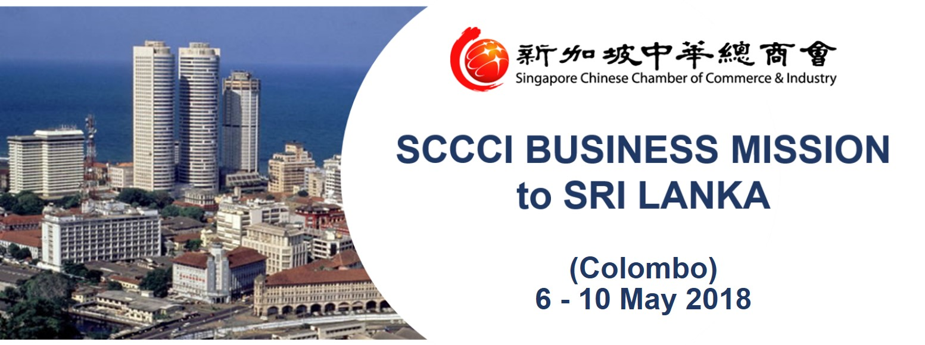

**OVERVIEW**

In January 2018, Prime Minister Lee Hsien Loong will be visiting Sri Lanka for the occasion of signing of Singapore’s Free Trade Agreement with Sri Lanka to promote stronger economic ties and enhance trade flows by lowering barriers of entry and providing increased market access for Singapore and Sri Lankan companies.

Thus, to meet the demand of the keen interest of several companies to explore this upcoming market, the Singapore Chinese Chamber of Commerce and Industry, together with IE Singapore and High Commission of Sri Lanka, will be organizing a 5 Days Business Mission to Sri Lanka, with the following objectives: -

* Gain an in-depth understanding of the investment environment and first-hand information on doing business in Sri Lanka
* Discover business opportunities and visit port city development projects and local Sri Lanka conglomerates companies.
* Network with key government agencies, business leaders and business associations, to understand Sri Lanka’s economic & investment climate and polices and find partners for meaningful collaboration between Singapore and the country.

**OVERVIEW**

**TENTATIVE PROGRAMME**

|  |
| --- |
| **Day 1 6 May 2018 (Sun) Singapore – Colombo** |
| - Depart for Bandaranaike International Airportvia Singapore Airlines (*SQ468 ETD 2240 ETA 2355*)  - Arrival at Cinnamon Grand Colombo (5* International Hotel) |
| **Day 2 7 May 2018 (Mon) Colombo** |
| * Meeting with Ministry of Development Strategies and International Trade * Networking Lunch and Sharing session by Prima Group * Visit to Port city development projects * Meeting with China Merchant Port (MCP) * Networking Dinner with Sri Lanka Overseas Chinese Association (SLOCA) |
| **Day 3 8 May 2018 (Tue) Colombo** |
| * Sharing on legal, tax and regulations in Sri Lanka by KPMG * Sharing of Sri Lanka business environment and potential opportunities by Board of Investment * Sharing session by Ley Choon Group Holdings Limited * Networking Lunch with prominent local companies * Business networking with Sri Lanka-Singapore Business Council (SLSBC) and Ceylon Chamber of Commerce (CCC) * Networking Dinner with Singapore business based companies, Sri Lanka companies and government officials |
| **Day 4 9 May 2018 (Wed) Colombo** |
| - Visits of Sri Lanka conglomerates  - Networking Lunch  - Visits of Sri Lanka conglomerates  - Networking Dinner and Business Sharing Experiences by Singaporean local firms in Sri Lanka |
| **Day 5 10 May 2018 (Thur) Colombo - Singapore** |
| - Depart from Colombo to Singapore via Singapore Airlines (*Midnight flight SQ469 ETD 0110 ETA 0740) |

**\* Programme is tentative and subject to changes**

**ORGANISATION PROFILES**

|  |
| --- |
| **MINISTRY OF DEVELOPMENT STRATEGIES AND INTERNATIONAL TRADE**  The Ministry of Development Strategies and International Trade assist to promote and strategize Sri Lanka’s global competitiveness in international trade by providing high value-added goods and services through innovations, quality investment and increased market access.  Website: <http://modsit.gov.lk/> |
| **PRIMA GROUP**  Prima Limited of Singapore was established in 1961, pioneering flour milling in the Asian region. Growing from strength to strength, the multinational industrial group today has extended its network of operations across Asia to Malaysia, Indonesia, Australia, Hong Kong, China and Sri Lanka. Today, the Prima Group’s business interests include a significant presence in the sectors of flour milling, feed milling, food manufacturing and services, supply of bakery equipment and systems, bakery industry training, information technology and food science research in the region.  Website: <http://www.prima.com.lk/Default.aspx> |
| **CHINA MERCHANT PORT (MCP)**  China Merchant Port is the largest public port operator in China with investments in Mainland China, Hong Kong and overseas. Its nationwide port network expands across the Bohai Economic Zone, the Yangtze River Delta, the Xiamen Bay Economic Zone, the Pearl River Delta, and the Southwest region, includes the coastal hub ports in Hong Kong, Shenzhen, Ningbo, Shanghai, Qingdao, Tianjin, Xiamen Bay, Zhanjiang and Shantou. Having broadened the regional focus from China to worldwide market since 2008, CMPort has a network across 5 continents, 16 countries and 31 ports. Benefited from China national initiative “One Belt One Road”, CMPort has further strengthened its position in the Belt and Road markets in recent years. Throughput handled in Year 2016 was 95.77 million TEU (up by 14.2% against Year 2015).  Website: <http://www.cmport.com.hk/en/> |
| **SRI LANKA OVERSEAS CHINESE ASSOCATION (SLOCA)**  The Sri Lanka Overseas Chinese Association (SLOCA) is a non-political and non-profit organization united with the overseas Chinese, Chinese, overseas students, as well as the overseas Chinese Companies.  Website: <http://www.sloca.net/> |
| **KPMG SRI LANKA**  KPMG is a global network of independent member firms offering audit, tax and advisory services. The firms work closely with clients, helping them to mitigate risks and grasp opportunities.  Member firms' clients include business corporations, governments and public sector agencies and not-for-profit organizations. They look to KPMG for a consistent standard of service based on high order professional capabilities, industry insight and local knowledge.  Website: <https://home.kpmg.com/xx/en/home.html> |
| **BOARD OF INVESTMENT**  The Board of Investment(BOI) of Sri Lanka acted as an engine of growth creating a considerable impact on the country's economic development. The BOI is structured to function as a central facilitation point for investors and is committed towards continuously improving of the country's investment climate.  Website: <http://www.investsrilanka.com/> |
| **LEY CHOON GROUP HOLDING LIMITED**  Ley Choon Constructions and Engineering Pte Ltd, is an established one-stop Underground Utilities Infrastructure service provider based in Singapore. The core businesses comprise i) [Pipes and Roads Segment](http://www.leychoon.com/?page_id=24), consisting of Underground Utilities Infrastructure construction and maintenance, sewer pipeline rehabilitation, road and airfield construction and maintenance; and ii) [Construction Materials Segment](http://www.leychoon.com/?page_id=332), comprising asphalt premix production and construction waste recycling.  Website: <http://www.leychoon.com/> |
| **CEYLON CHAMBER OF COMMERCE (CCC)**  Founded in the year 1839, The Ceylon Chamber of Commerce (CCC) is the oldest business Chamber in the Indian Ocean Island of Sri Lanka. Their members range from sole proprietor to the multinational, encompasses virtually every sphere of economic activity in Sri Lanka – industry, shipping, engineering, mining, consultancy services, wholesale retail, financial services, legal and other services. Their focal point for business contacts both locally and abroad and have many specialized committees, affiliated associations and bilateral business councils under their wings.  Website: <https://www.chamber.lk/> |

*\*Visiting companies are subject to change*

**ESTIMATED COST**

|  |  |
| --- | --- |
| **Cost Description** | **Cost** |
| International airfare from Singapore (SIN) to Colombo (CMB):  Economy Class  Business Class  *\*fare & taxes subject to change and seats subject to availability* (Airline terms & conditions applies)* | From: S$692  From: S$2,102 |
| Accommodation   * 3 nights at Cinnamon Grand Colombo * Single Room * Twin Room | S$788 (per participant)  S$833 (shared by 2 participants) |
| Common Fund   * Local transport * Meals * Collateral printing * Other misc expenses   (inclusive of all taxes in Sri Lanka which cost around 30% tax) | S$1,350 (SCCCI Member)  S$1,500 (Non-Member) |
| **Total Cost**  **(Inclusive of airfare, accommodation and common fund)**  **SCCCI Member**  **Non-Member** | **S$ 2,830** (per participant)  **S$ 2,980** (per participant)  **\*Estimated cost per delegate** |

This mission is supported under the iMAP funding by IE Singapore. The common fund is a subsidized rate after support funding from IE Singapore. Due to limited capacity, each company is allowed to send a maximum of 2 representatives for the mission.

**Accolade, a brand by Pacific Arena Pte Ltd** has been appointed to **handle flight reservations and visa applications.** For payment of airfare and more information, please contact **Ms Shermaine Tang** at Tel: 6317 2808, Fax: 6317 2822 or Email: projects@accolade.events

Ground transport to and from the airport will be provided to participants travelling with mission officials. Owing to limited seats, priority will be given to SCCCI members on a first-come-first-served basis. Please register early to avoid disappointment. A **Pre-Mission Briefing will be conducted closer to the departure date.**

For **Non-Singaporeans** residing in Singapore**,** please check with **Accolade** whether would you need a visa. **Accolade** will also be able to apply on your behalf, please note that additional service fee may apply.

**(5) TERMS OF PARTICIPATION**

By virtue of agreeing to participate in the above Mission, the participant and/or the company/organisation he represents, agree to the following terms of participation:

1. All participants are strongly advised to arrange visa documents (if required) and purchase full insurance coverage for their overseas travel needs. We recommend all participants to insure themselves with the necessary coverage for overseas travel, medical, emergency evacuation and trip cancellations/ interruptions, etc.
2. The Singapore Chinese Chamber of Commerce & Industry (SCCCI) shall be fully indemnified against any liability whatsoever resulting from or in the event of death, injury, loss or damage to property incurred during the course of the Mission.
3. SCCCI reserves the right, without prior notice, to make changes and/or amendments to the Mission programme, in part or in whole for the Mission, as it deems fit or as the circumstances dictate.
4. Mission participants who make their own flight and hotel accommodation arrangements are strongly advised to update themselves with the latest programme and ensure that they meet up with the main group punctually at the designated locations. SCCCI will not be held liable should mission participants fail to turn up punctually for meetings or activities organized in this Mission.
5. SCCCI shall not be responsible in any way for loss, injury or damage arising from acts of God, acts of governments or de facto authority, war, civil unrest, any kind of hostilities, strikes, theft, sickness, quarantine, immigration or customs regulations, hijacking, acts of lawlessness or terrorism, forces of nature, breakdown, delay, cancellation, error, omissions or any other cause beyond our control.
6. Cancellations must be made to SCCCI in writing. Please note that cancellation fees apply as follows:
   1. Cancellations received 30 days or more prior to departure, Participants liable to pay 50% of the common fund.
   2. Cancellations received 15 to 29 days prior to departure, Participants liable to pay 70% of the common fund.
   3. Cancellations received less than 15 days prior to departure, Participants liable to pay full sum of the common fund.
   4. Please note that the Participants are also liable for the cancellation policies dictated by the airlines and hotel.

For enquiries, please contact Ms Tiffany Shia at [tiffany@sccci.org.sg](mailto:tiffany@sccci.org.sg) or 6430 8312.

|  |  |  |  |  |  |  |
| --- | --- | --- | --- | --- | --- | --- |
| **REGISTRATION FORM – SCCCI BUSINESS MISSION TO SRI LANKA (COLOMBO),**  **6 – 10 MAY 2018**  **Please type out the form in softcopy and email to** [tiffany@sccci.org.sg](mailto:tiffany@sccci.org.sg) | | | | | | |
| Attention: Ms Tiffany Shia, Commerce & Industry Development, SCCCI | | | | | | |
| Please put a "" in the appropriate boxes   * I will make my own flight arrangements for this study mission to Sri Lanka (Colombo). * I would like to engage **Accolade, a brand by Pacific Arena Pte Ltd** for my air ticket/ visa arrangements.  |  |  |  |  |  | | --- | --- | --- | --- | --- | | **S/N** | **Details** | **Please indicate your choice** (*Including taxes, and subject to change)* | | **Payment to be made directly to:** | | **1** | **International Air Fare**  SIN/CMB SQ468  6 May (Sun) 2240/2355  CMB/SIN SQ469  10 May (Thu) 0110/0740 | Economy Class:  Business Class: | From S$ 692  From S$ 2,102  *(based on restricted fare)*  *\*\*Airline terms & conditions apply* | **Pacific Arena Pte Ltd** | | **2** | **Hotel Accommodation** | Single Room:  Twin Room: | S$ 788  S$ 833  Name of participant sharing with: _____________________  (Fee shared by 2 participants) | SCCCI | | **3** | **Common Fund** | SCCCI Member:  Non-Member: | S$ 1,350  S$ 1,500 | SCCCI | | | | | | | |
| Information provided will be used for the Mission Brochure and/or Mission-related purposes. | | | | | | |
| **PERSONAL INFORMATION 个人资料** | | | | | | |
| Title: ☐ Mr. ☐ Ms. | | *Please complete the form in English. | | | | |
| Participant Name | | | | Designation | | |
| Company Name | | | | | Website | |
| Tel | Fax | | Mobile | | E-mail | |
| Business Address | | | | | | |
| Company writeup (up to 100 words) | | | | | | |
| Drug Allergies (if any) | | | | Medical History (if any) | | |
| Special Dietary Requirements | | | | | | |
| In event of emergencies, please indicate Next of Kin / Contact Person & Contact Number | | | | | | |

**Important information to take note and payment method:**

1) Please make payment via Bank transfer for **item 1 (air ticket/visa)** to Accolade, a brand by Pacific Arena Pte Ltd.

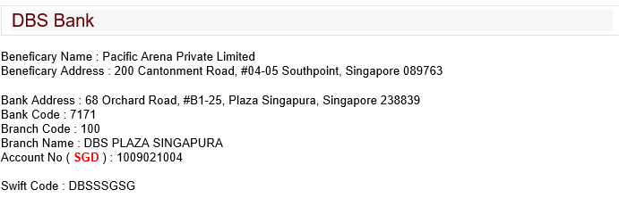

or

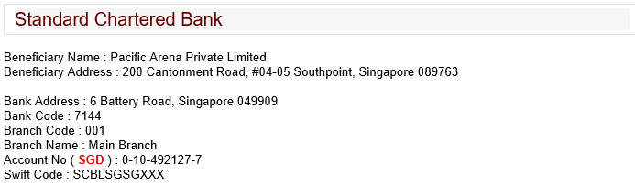

2) Please mail the cheque payment for **items 2 and 3 (hotel accommodation and common fund)**

Payable to: **SCCCI**

Send cheque to: **9 Jurong Town Hall Road, #04-01 Trade Association Hub, Jurong Town Hall, S(609431)**

Attention it to:**Ms Tiffany Shia**

3) Please **email** a **passport-size colour photo and a copy of your passport** to [tiffany@sccci.org.sg](mailto:tiffany@sccci.org.sg) .

*Your passport copy is required for travel bookings and hotel check-in purposes. You may refer to www.sccci.org.sg for our privacy policy.*