Organised by: Supported by:
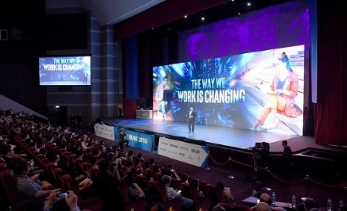
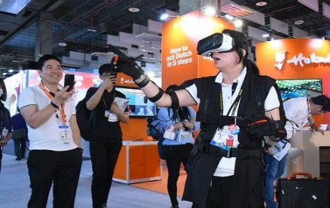
Visit Computex Taipei 2019
Building Global Technology Ecosystems

Date: 27 - 31 May 2019 | Location: Taipei
Cost: S$1,650* (member, after grant) | S$1,800* (non-member, after grant)
*A grant of S$500** for each company only upon approval. To qualify for the grant, please submit your registration to us by 21st December 2018.
Target Audiences: Technology, Information and Communication Sector
- Cost includes accommodation (single room) and common fund (local transport, 2 lunch and 1 dinner, misc expenses) only.
- Due to limited vacancy, priority will be reserve for companies from the technology, information and communication sector.
**S$500 is only an estimated amount.
For enquiries, please contact Ms Tiffany Shia at tiffany@sccci.org.sg or 6430 8312
During the 5 days trip, participants will get to gather new ideas and innovation practices to reshaping consumer’s experience to opening up new business opportunities in new markets, eg. the Internet of Things (IoT), AI, Blockchain, and other new suit of smart technologies that can drive innovation to revolutionise business.
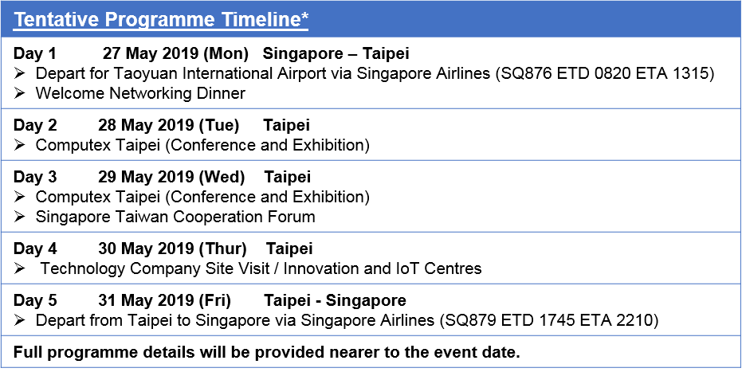
The trip includes Technology Company site visits, visit of Innovation and IoT centres, business networking opportunities, 2-day visit to the Computex 2019 Taipei Exhibition, featuring some of Taiwan’s best IoT technologies, innovations and best practices that continue to breathe new life into service and product offerings and Networking opportunities

2019年台北国际电脑展暨创新科技考察团
“链接未来 携手共进”

日期: 2019年5月27日至31日 | 地点: 台北
参加费用: S$1,650* (政府津贴后之会员价) | S$1,800* (政府津贴后之非会员价)
*报名或批准后，每家企业只能享有一次S$500**的津贴。请于2018年12月21日前报名以获取津贴资格
目标参加者: 资讯科技行业
- 参加费用含酒店住宿（单人房）及共同费用（当地交通、2次午餐、1次晚餐和杂项费用）
- 由于名额有限，来自资讯科技领域的企业将有优先报名权
**S$500的津贴为预估数额
如有任何询问，可通过电邮(tiffany@sccci.org.sg)或拨电(6430 831)联系谢斯琪小姐。
立即点击报名
为期5天的考察团，参与者将有机会以新的角度及思维，探索客户服务体验的创新实践方法，并利用此优势拓展新商机，发掘新市场。参与者将亲身体验物联网、人工智能及区块链等创新智能技术为企业带来的无限可能。
此次考察团将带领参与者前往科技企业考察及参访创新物联网中心，并与当地商家交流商业资讯，建立人脉。此行中的两天也将参观2019年台北国际电脑展，除了与科技业界翘楚建立商业联系之外，也同时考察台湾发展最前沿的物联网科技技术及创新应用模式，学习如何为客户服务和产品注入创新元素。
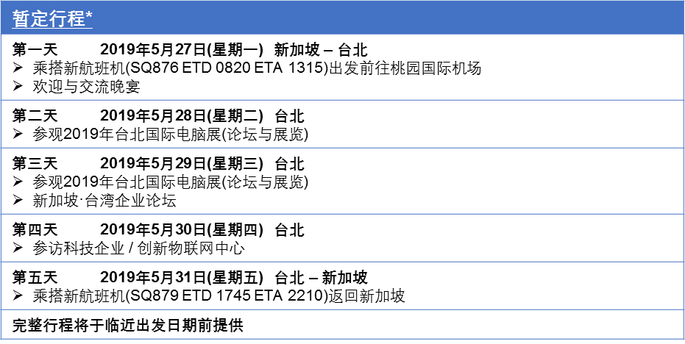

Taiwan External Trade Development Council (TAITRA)
Founded in 1970, TAITRA is Taiwan's foremost nonprofit trade promoting organization. Sponsored by the government and industry organizations, TAITRA assists enterprises to expand their global reach. Headquartered in Taipei, TAITRA has a team of 1,300 specialists and operates 5 local offices in Taoyuan, Hsinchu, Taichung, Tainan and Kaohsiung as well as 61 branches worldwide. Together with Taipei World Trade Center (TWTC) and Taiwan Trade Center (TTC), TAITRA has formed a global network dedicated to promoting world trade.

Website: http://www.taitra.org.tw/About-TAITRA

Computex Taipei
Established in 1981, COMPUTEX TAIPEI (also called COMPUTEX) is the leading global ICT and IoT show with a complete supply chain and ecosystems.
Co-organized by the Taiwan External Trade Development Council (TAITRA) and Taipei Computer Association (TCA), COMPUTEX, based upon Taiwan’s complete ICT clusters, covers the whole spectrum of ICT industry, from established brands to startups and from ICT supply chain to IoT ecosystems.
With strong R&D and manufacturing capabilities and IPR protection, Taiwan is a strategic destination for foreign companies and investors looking for partners in global technology ecosystems.

Website: https://www.computextaipei.com.tw

ORGANISATION PROFILES

*Visiting companies are subject to change

ESTIMATED COST

Cost Description | Cost
International airfare from Singapore (SIN) to Taipei (TPE)  - Please kindly arrange your own flight arrangements.  Flight Details:  SIN/TPE SQ876 via Singapore Airline  27 May (Mon) 0820/1315  TPE/SIN SQ879 via Singapore Airline  31 May (Fri) 1745/2210 | Self-Arrangement
Accommodation  - 4 nights at Caesar Park Taipei  - Single  - Twin / Double Room | S$1,000  S$1,100
Common Fund  - Local transport  - Meals  - Collateral printing  - Other misc expenses  (inclusive of all taxes in Taipei) | S$1,150 (SCCCI Member)  S$1,300 (Non-Member)
Total Cost Before Grant  (Inclusive of accommodation and common fund)  SCCCI Member  Non-Member | S$ 2,150 (per participant)  S$ 2,300 (per participant)  *Estimated cost per delegate
Total Cost After Grant  SCCCI Member  Non-Member  **A grant of S$500 for Each Company only upon approval by TAITRA HQ | **S$1,650 (per participant)  **S$1,800 (per participant

Ground transport to and from the airport will be provided to participants travelling with mission officials. Owing to limited seats, priority will be given to SCCCI members on a first-come-first-served basis. Please register early to avoid disappointment. A Pre-Mission Briefing will be conducted closer to the departure date.
For Non-Singaporeans residing in Singapore, please check with a travel agent whether would you need a visa. Additional service fee may apply and is not included in the package.
TERMS OF PARTICIPATION
By virtue of agreeing to participate in the above Mission, the participant and/or the company/organisation he represents, agree to the following terms of participation:

- All participants are strongly advised to arrange visa documents (if required) and purchase full insurance coverage for their overseas travel needs. We recommend all participants to insure themselves with the necessary coverage for overseas travel, medical, emergency evacuation and trip cancellations/ interruptions, etc.

- The Singapore Chinese Chamber of Commerce & Industry (SCCCI) shall be fully indemnified against any liability whatsoever resulting from or in the event of death, injury, loss or damage to property incurred during the course of the Mission.

- SCCCI reserves the right, without prior notice, to make changes and/or amendments to the Mission programme, in part or in whole for the Mission, as it deems fit or as the circumstances dictate.

- Mission participants who make their own flight and hotel accommodation arrangements are strongly advised to update themselves with the latest programme and ensure that they meet up with the main group punctually at the designated locations. SCCCI will not be held liable should mission participants fail to turn up punctually for meetings or activities organized in this Mission.

- SCCCI shall not be responsible in any way for loss, injury or damage arising from acts of God, acts of governments or de facto authority, war, civil unrest, any kind of hostilities, strikes, theft, sickness, quarantine, immigration or customs regulations, hijacking, acts of lawlessness or terrorism, forces of nature, breakdown, delay, cancellation, error, omissions or any other cause beyond our control.

- Cancellations must be made to SCCCI in writing. Please note that cancellation fees apply as follows:
  - Cancellations received 30 days or more prior to departure, Participants liable to pay 50% of the common fund.
  - Cancellations received 15 to 29 days prior to departure, Participants liable to pay 70% of the common fund.
  - Cancellations received less than 15 days prior to departure, Participants liable to pay full sum of the common fund.
  - Please note that the Participants are also liable for the cancellation policies dictated by the airlines and hotel.

For enquiries, please contact Ms Tiffany Shia at tiffany@sccci.org.sg or 6430 8312.

REGISTRATION FORM – VISIT COMPUTEX TAIPEI 2019
Please ensure that all details are filled accordingly to be eligible for the grant and submit it in softcopy words format to Ms Tiffany Shia at tiffany@sccci.org.sg or call 6430 8312 for enquiries. Incomplete application forms will be rejected.
NOTE: * needs to be completed
*Exhibition | COMPUTEX 2019
*Company Name | (Eng) (Chinese)
*Company Address
*Company Email
*Nature of Business
*Telephone | +65- |  |  |  |  |  | *Fax | +65-
*Website (Compulsory Information – For companies without website, please revert with brochure of company profile or product listing) |  |  |  |  | www.
*Company writeup (up to 100 words in both English and Chinese) |  |  |  |  | (You may submit the company writeup on a separate word file in both English and Chinese)
*Annual Sales Revenue (US$) |  |  |  |  | 2017 |  |  |  | 2018
Annual Procurement (US$) |  |  |  |  | 2017 |  |  |  | 2018
*Does your company participate in Government Procurement Projects? |  |  |  |  | Yes / No  If Yes, Please state some project examples:
*E-commerce url (please note company’s online shopping site)
Procurement Item(s): Please indicate below the planned purchasing products or service, along with the detailed products description and estimated order quantity.
* Product Name |  |  | *Specification |  |  |  |  |  |  | *Amount or Quantity (US$)
*Participant’s Details & Other Information
* Full Name on Passport
* Full Name on Name Card |  |  | (Eng) (Chi)
* Title/ Designation |  |  | (Eng) (Chi) |  |  |  | * Mobile No.
*Nationality |  |  |  |  |  |  | * E-mail
Have you ever visited any Taipei Trade Show? |  |  |  |  |  |  | Y / N
Have you ever been rendered incentive by TAITRA this year? If yes, please indicate name of trade show attended.
Drug Allergies (if any) |  |  |  |  |  |  | Medical History (if any)
Special Dietary Requirements
In event of emergencies, please indicate Next of Kin / Contact Person & Contact Number
*Accommodation and Common Fund
(Please ticket accordingly)
*Hotel Accommodation |  | Single Room:  Twin Room: |  |  |  | S$ 1,000  S$ 1,100  Name of participant sharing with: __________________________  (Fee shared by 2 participants)
*Common Fund |  | SCCCI Member:  Non-Member: |  |  |  | S$ 1,150  S$ 1,300
*Important Information to Submit and Note
1) Please email a passport-size colour photo, a copy of your passport and flight e-ticket(after purchasing) to tiffany@sccci.org.sg .
*Your passport copy is required for travel bookings and hotel check-in purposes. You may refer to www.sccci.org.sg for our privacy policy.*
2) Air ticket, travel insurance and visa (if applicable) is not included in the package.
3) To qualify for hotel accommodation, applicants will have to be Singapore-registered company in relevant industry to meet the minimum requirement of USD 300,000 in annual sales revenue.
4) Please ensure the details on the name card is the same as that in your application form. TAITRA reserve the right to revoke the subsidy should there be any discrepancies.
5) All applications are subjected to final approval from TAITRA HQ.
6) Participant’s participation will only be confirmed upon receiving the confirmation email from SCCCI.
7) Information provided will be used for Grant, Mission Brochure and/or Mission-related purposes.
*Terms of Participation
By virtue of agreeing to participate in the above Mission, the participant and/or the company/organisation he represents, agree to the following terms of participation:

- All participants are strongly advised to arrange visa documents (if required) and purchase full insurance coverage for their overseas travel needs. We recommend all participants to insure themselves with the necessary coverage for overseas travel, medical, emergency evacuation and trip cancellations/ interruptions, etc.

- The Singapore Chinese Chamber of Commerce & Industry (SCCCI) shall be fully indemnified against any liability whatsoever resulting from or in the event of death, injury, loss or damage to property incurred during the course of the Mission.

- SCCCI reserves the right, without prior notice, to make changes and/or amendments to the Mission programme, in part or in whole for the Mission, as it deems fit or as the circumstances dictate.

- Mission participants who make their own flight and hotel accommodation arrangements are strongly advised to update themselves with the latest programme and ensure that they meet up with the main group punctually at the designated locations. SCCCI will not be held liable should mission participants fail to turn up punctually for meetings or activities organized in this Mission.

- SCCCI shall not be responsible in any way for loss, injury or damage arising from acts of God, acts of governments or de facto authority, war, civil unrest, any kind of hostilities, strikes, theft, sickness, quarantine, immigration or customs regulations, hijacking, acts of lawlessness or terrorism, forces of nature, breakdown, delay, cancellation, error, omissions or any other cause beyond our control.

- Cancellations must be made to SCCCI in writing. Please note that cancellation fees apply as follows:
  - Cancellations received 30 days or more prior to departure, Participants liable to pay 50% of the common fund.
  - Cancellations received 15 to 29 days prior to departure, Participants liable to pay 70% of the common fund.
  - Cancellations received less than 15 days prior to departure, Participants liable to pay full sum of the common fund.
  - Please note that the Participants are also liable for the cancellation policies dictated by the airlines and hotel.

